**SFTP Steps:**

1. **Rebex Tiny SFTP Server (free) downloaded from the internet through this link**

[**https://labs.rebex.net/tiny-sftp-server**](https://labs.rebex.net/tiny-sftp-server)

1. **Extract the zip file and run the RebexTinySFTPServer application and click start button.**

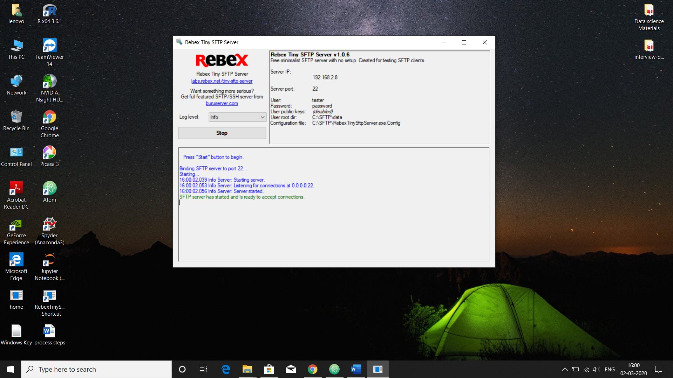

1. **Change the ServerIP to 192.168.2.8, ServerPort to 22, User : tester, Password : password in the test_cred.py file like this and One_drive_file_path is the local system path.**
2. 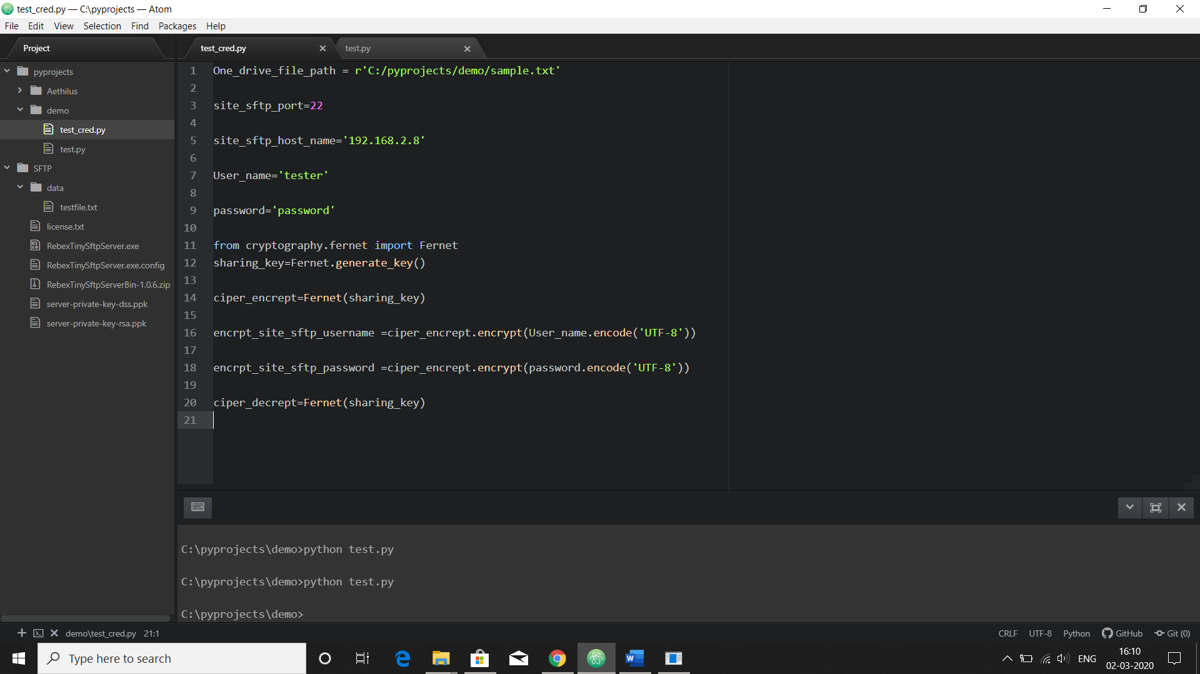
3. **cryptography is used for encrypting and decrypting the data to transfer the files in secure manner.**
4. **Loging module is used for save the log details about the file. I created example.log file to store all log details in that file**

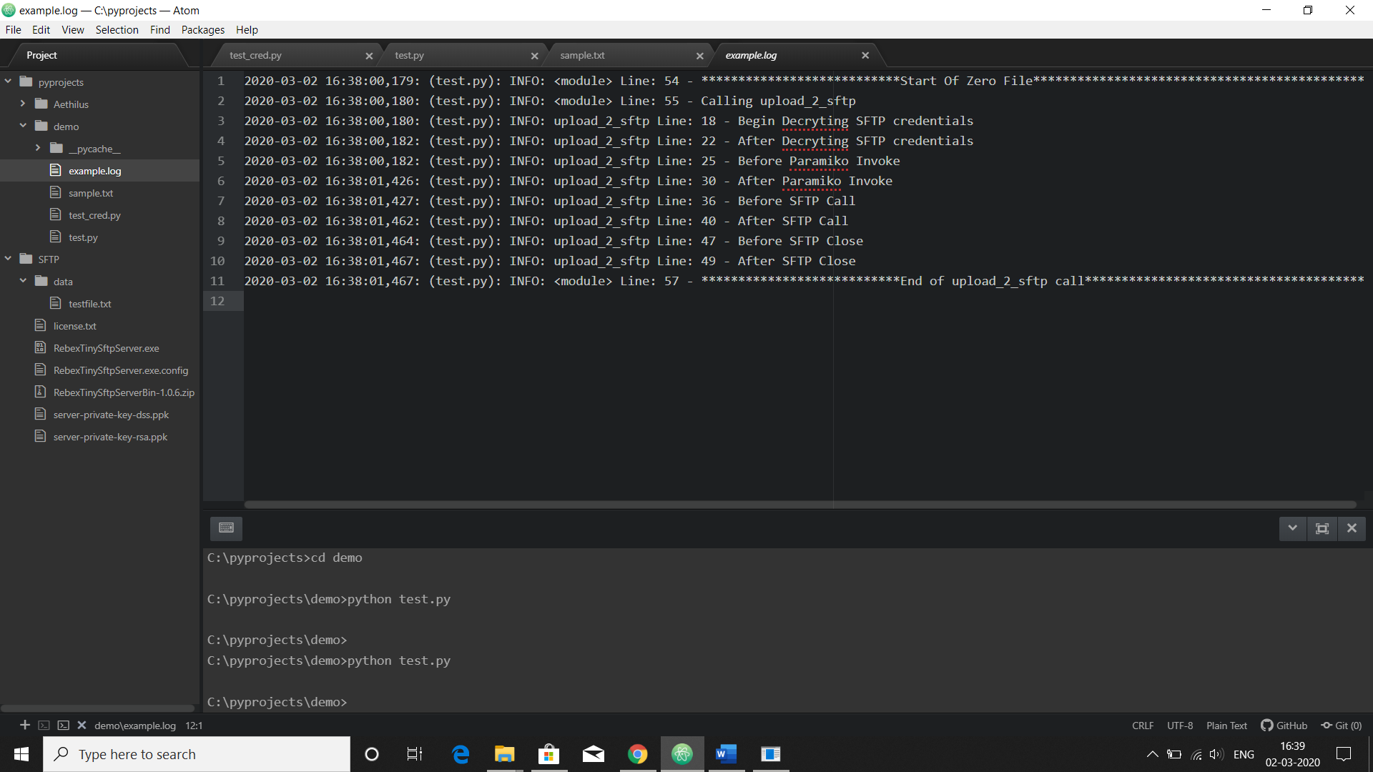

1. **Paramiko module is used for upload local file to the sftp server and sftp server file download into local system.**
2. **sftp.get('testfile.txt',test_cred.One_drive_file_path)=🡺SFTP Server file download into a local system.**

**testfile.txt is SFTP Server root file download into a local system as sample.txt like this..**

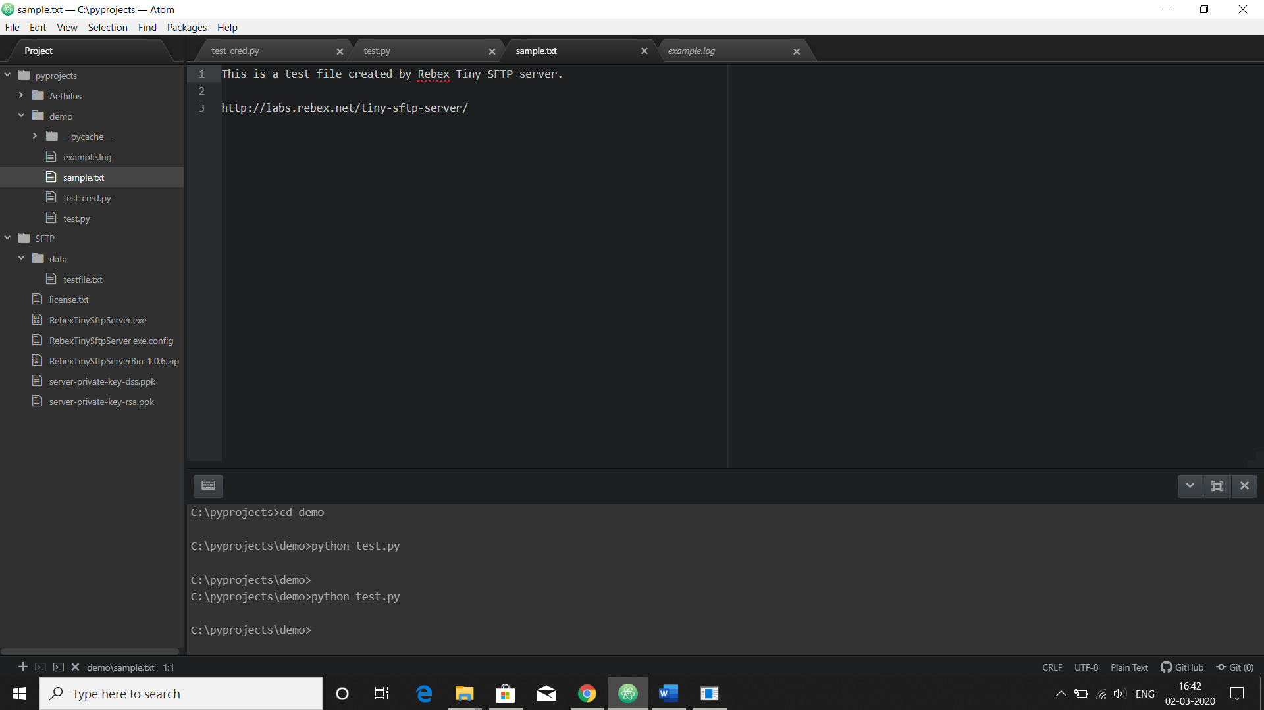

1. **sftp.put('saikiran.txt','/./saikiran.txt') #...local system file upload into a SFTP Server.**

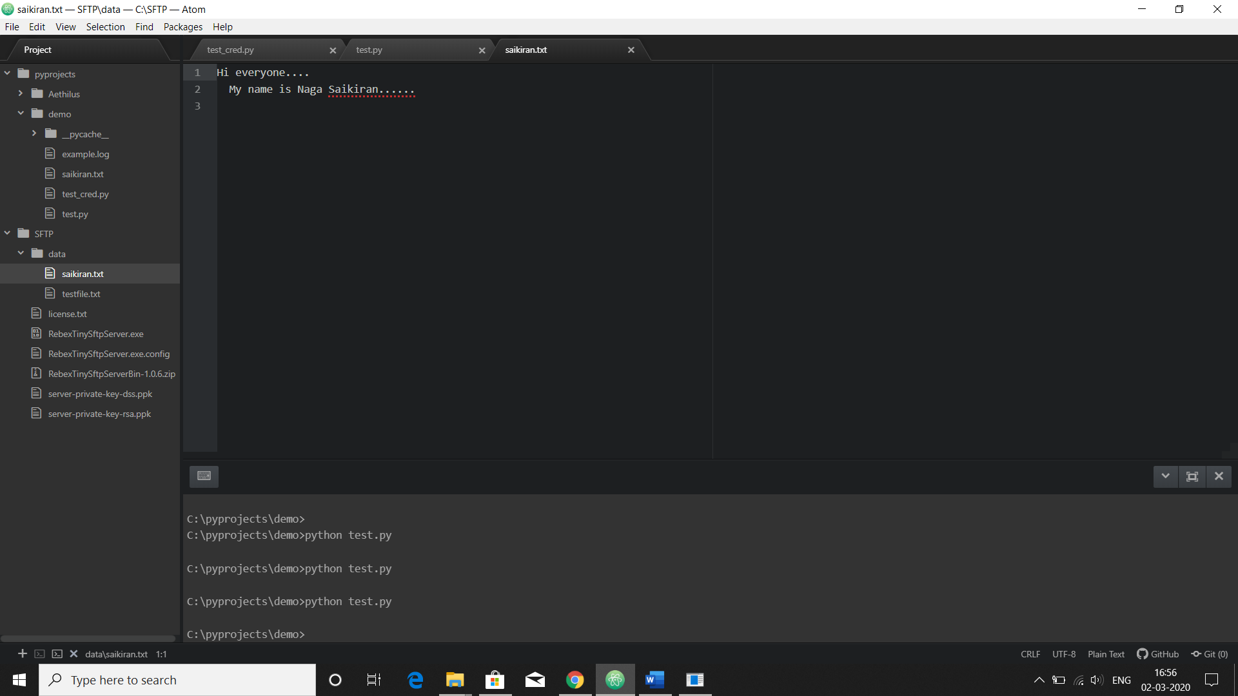

1.SFTP.rar file contains Server files and the root folder is data.

2. Local.rar file contains test.py and test_cred.py

3. Extract these 2 rar files and open the SFTP folder and run the RebexTinySFTPServer application and click start button.

4.Now open the Local folder and run the test.py file.

5.First it shows the list what files are available in the SFTP server root folder

6.Then we select one excel file with extension. Now it will start the process like…..

1. Download that particular excel file from server and do some modification like adding rows and columns and save file with the name of modified excel
2. Finally that modified excel file upload into the server root file automatically.